**Practical-6**

**Implement program for randomized version of quick sort and compare its performance with normal version of quick sort using steps count on various number of inputs.**

**Randomized Quicksort:**

**Code:**

**#include <cstdlib>**

**#include <time.h>**

**#include <iostream>**

**using namespace std;**

**int partition(int arr[], int low, int high)**

**{**

**int pivot = arr[high];**

**int i = (low - 1);**

**for (int j = low; j <= high - 1; j++)**

**{**

**if (arr[j] <= pivot) {**

**i++;**

**swap(arr[i], arr[j]);**

**}**

**}**

**swap(arr[i + 1], arr[high]);**

**return (i + 1);**

**}**

**int partition_r(int arr[], int low, int high)**

**{**

**srand(time(NULL));**

**int random = low + rand() % (high - low);**

**swap(arr[random], arr[high]);**

**return partition(arr, low, high);**

**}**

**void quickSort(int arr[], int low, int high)**

**{**

**if (low < high) {**

**int pi = partition_r(arr, low, high);**

**quickSort(arr, low, pi - 1);**

**quickSort(arr, pi + 1, high);**

**}**

**}**

**void printArray(int arr[], int size)**

**{**

**int i;**

**for (i = 0; i < size; i++)**

**cout<<arr[i]<<" ";**

**}**

**int main()**

**{**

**int arr[] = { 10, 7, 8, 9, 1, 5 };**

**int n = sizeof(arr) / sizeof(arr[0]);**

**quickSort(arr, 0, n - 1);**

**printf("Sorted array: \n");**

**printArray(arr, n);**

**return 0;**

**}**

**Output:**

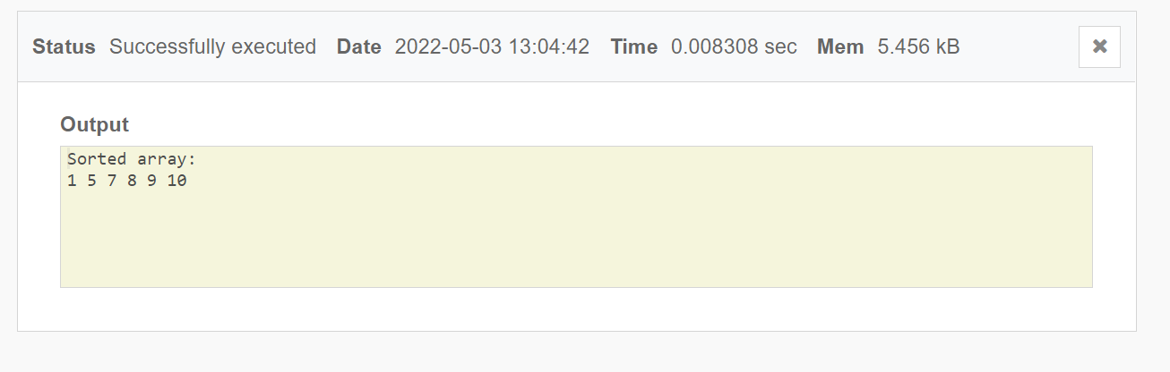

**Randomized Quicksort:**

|  |  |
| --- | --- |
| **SIZE OF ARRAY** | **TIME COMPLEXITY** |
| **5** | 0.007585 |
| **10** | 0.007730 |
| **15** | 0.007835 |
| **20** | 0.007630 |
| **25** | 0.007840 |

**Quick sort:**

**Code: #include <bits/stdc++.h> using namespace std;**

**void swap(int* a, int* b)**

**{**

**int t = *a; *a = *b;**

**\*b = t;**

**}**

**int partition (int arr[], int low, int high)**

**{**

**int pivot = arr[high]; int i = (low - 1);**

**for (int j = low; j <= high - 1; j++)**

**{**

**if (arr[j] < pivot)**

**{ i++;**

**swap(&arr[i], &arr[j]);**

**}**

**}**

**swap(&arr[i + 1], &arr[high]);**

**return (i + 1);**

**}**

**void quickSort(int arr[], int low, int high)**

**{**

**if (low < high)**

**{**

**int pi = partition(arr, low, high);**

**quickSort(arr, low, pi - 1);**

**quickSort(arr, pi + 1, high);**

**}**

**}**

**void printArray(int arr[], int size)**

**{**

**int i;**

**for (i = 0; i < size; i++)**

**cout << arr[i] << " "; cout << endl;**

**}**

**int main()**

**{**

**int arr[] = {10, 7, 8, 9, 1, 5};**

**int n = sizeof(arr) / sizeof(arr[0]); quickSort(arr, 0, n - 1); cout << "Sorted array: \n";**

**printArray(arr, n);**

**return 0;**

**}**

**Output:**

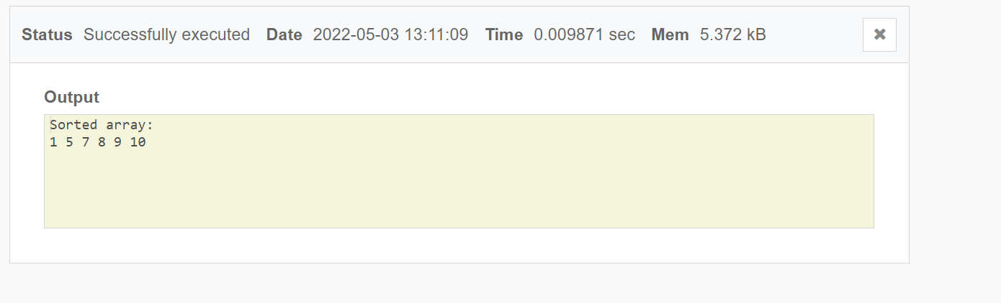

**Quick sort:**

|  |  |
| --- | --- |
| **Size of Array** | **Time complexity** |
| **5** | 0.006548 |
| **10** | 0.006736 |
| **15** | 0.007840 |
| **20** | 0.007770 |
| **25** | 0.008030 |

**Comparison:**

|  |  |  |
| --- | --- | --- |
| **Size of Array** | **RANDOMIZED QUICKSORT** | **QUICKSORT** |
| **5** | 0.007585 | 0.006548 |
| **10** | 0.007730 | 0.006736 |
| **15** | 0.007835 | 0.007840 |
| **20** | 0.007630 | 0.007770 |
| **25** | 0.007840 | 0.008030 |

**Conclusion:**

In this practical we analyzed randomized quicksort and it’s time complexity and later on we compared with simple quick sort by entering various input values.